**Introduction to the Five Machine Learning Steps**

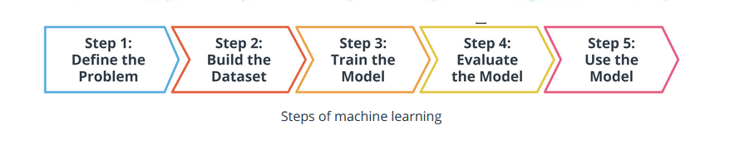

**Major Steps in the Machine Learning Process**

In the preceding diagram, you can see an outline of the major steps of the machine learning process. Regardless of the specific model or training algorithm used, machine learning practitioners practice a common workflow to accomplish machine learning tasks.

*These steps are iterative.* In practice, that means that at each step along the process, you review how the process is going. Are things operating as you expected? If not, go back and revisit your current step or previous steps to try and identify the breakdown.